1. A screenshot of a number of objects

   Description automatically generated
2. 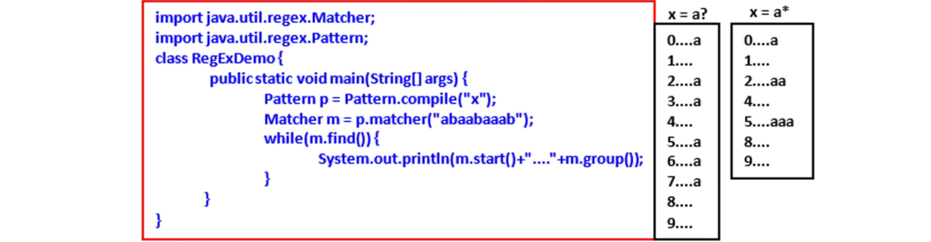  
   A white background with black text

   Description automatically generated
3. **Quantifier**:
   1. Number.
   2. How many.
   3. To specify the number of occurrences to match .
4. A table with numbers and lines

   Description automatically generated